

Key Travel’s offer for accommodation during the 19^{h} International Book Fair held in Prague on May 2013

All prices are in EUR | Single room | Double/twin room
Grand Majestic Plaza****  Truhlářská 16, Praha 1 | 115,- | 115,-
Ibis Praha Old Town***  Na Poříčí 5, Praha 1 | 90,- | 95,-
Central***  Rybná 8, Praha 1 | 74,- | 88,-
Belvedere***+  Milady Horákové 19, Praha 7 | 69,- | 83,-
Ibis Wenceslas Square***  Kateřinská 36, Praha 2 | 75,- | 80,-
Plaza Alta****  Ortenovo nám. 22, Praha 7 | 72,- | 75,-
Ibis Mala Strana***  Plzeňská 14, Praha 5 | 65,- | 70,-
Ibis Karlin***  Šaldova 54, Praha 8 | 56,- | 63,-

All above rates are per room per night including breakfast, VAT and local taxes.
Hotel reservation request should be sent to Key Travel lates by April 30th, 2013

Hotel Belvedere***+
Walking distance 10 minutes to Prague Exhibition Grounds where Book Fair is held.

Hotel Belvedere
Milady Horákové 19
170 00 Praha 7
www.hotelbelvedereprague.cz

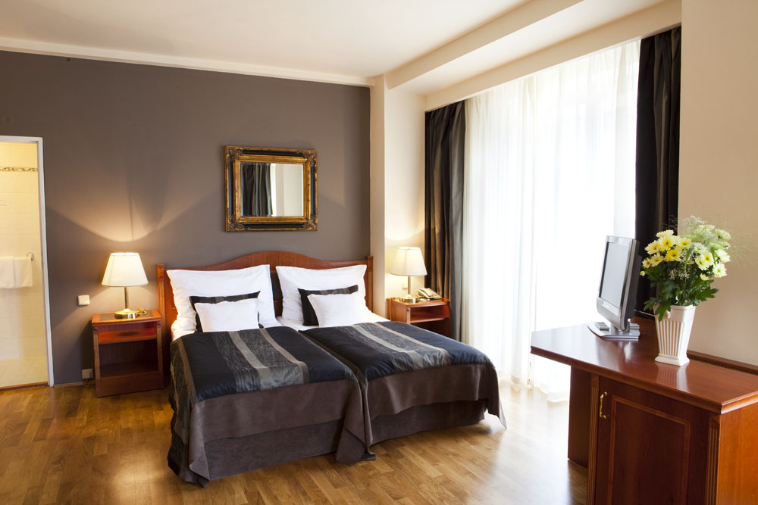

Hotel Central***
Direct connection by tram (10 minutes) to Prague Exhibition Grounds where Book Fair is held.

Hotel Central
Rybná 8
110 00Praha 1
www.central-prague.com

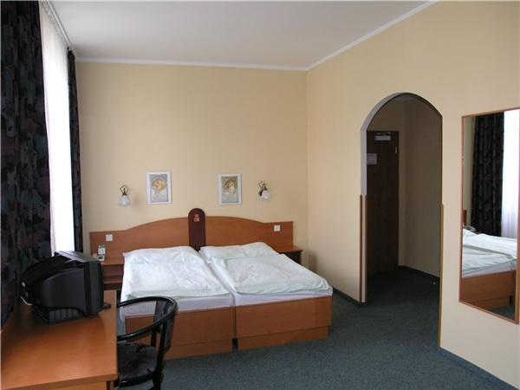

Grand hotel Majestic Praha****
Direct tram connection (10 minutes) to Prague Exhibition Grounds where Book Fair is held.

Hotel Grand hotel Majestic
Truhlářská 16
110 00 Praha 1
www.hotel-grandmajestic.cz

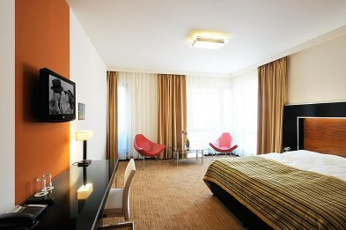

Hotel Plaza Alta ****
1,5 km walking or few minutes tram ride to Prague Exhibition Grounds where Book Fair is held.

Hotel Plaza Alta
Ortenovo nám.22
17000 Praha
www.hotelalta.com

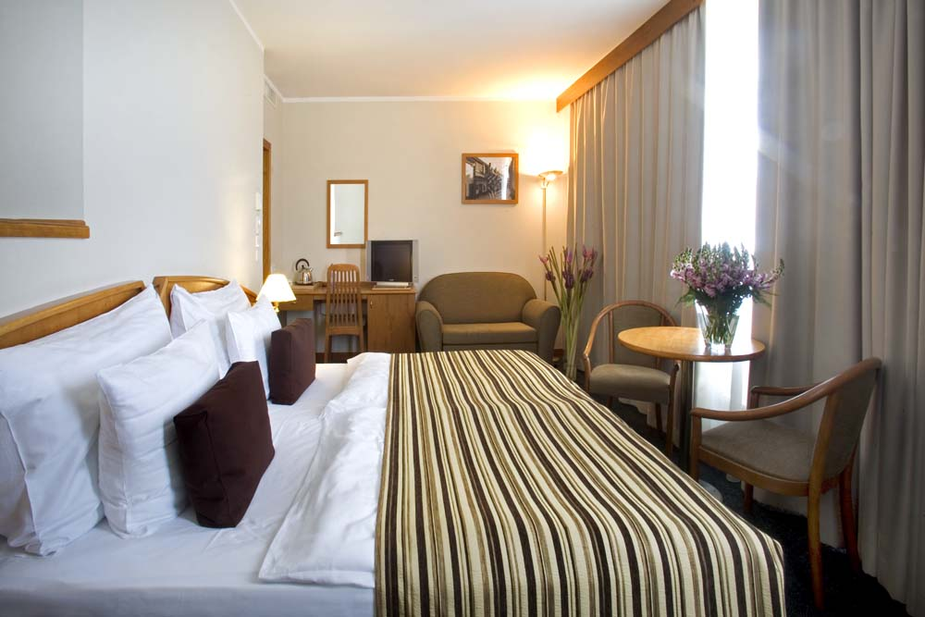

Hotel Ibis Mala Strana***
Direct connection (15 minutes) by tram to Prague Exhibition Grounds where Book Fair is held.

Ibis Mala Strana
Plzeňská 14
150 00 Praha 5
http://www.hotelibis.cz/hotely/ibis/10-2-1-homepage

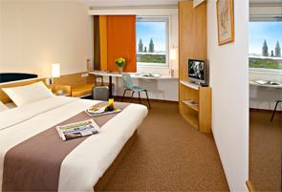

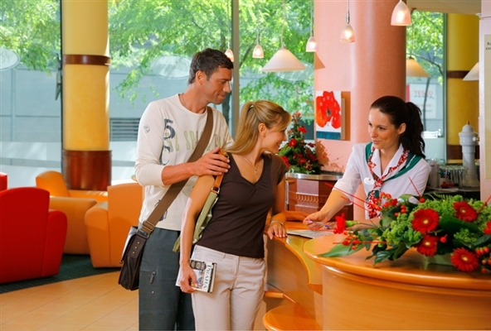

Hotel Ibis Old Town***
Direct connection (10 minutes) by tram to Prague Exhibition Grounds where Book Fair is held.

Ibis Old Town
Na Poříčíi 5
110 00 Praha 1
http://www.hotelibis.cz/hotely/ibis/10-0-1-ibis-info

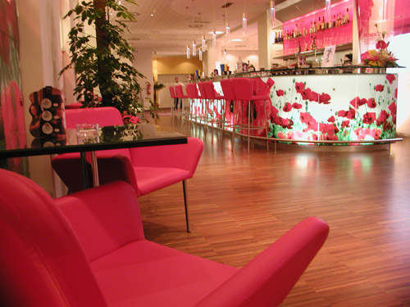

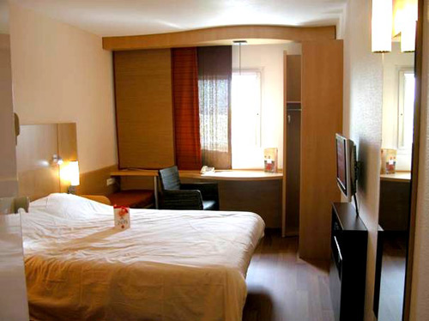

Hotel Ibis Wenceslas Square ***
Quick metro (C-line) connection to Prague Exhibition Grounds where Book Fair is held.

Ibis Wenceslas Square
Kateřinská 36
120 00 Praha 2
http://www.hotelibis.cz/hotely/ibis/10-3-0-homepage

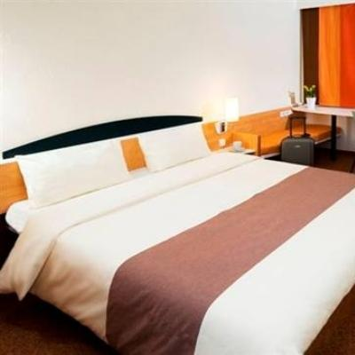

Hotel Ibis Karlin***
Quick connection (10-15 minutes) by tram to Prague Exhibition Grounds where Book Fair is held.

Hotel Ibis Praha Karlin
Šaldova 54
180 00 Praha 8
http://www.hotelibis.cz/hotely/ibis/10-1-1-ibis-info

